1)

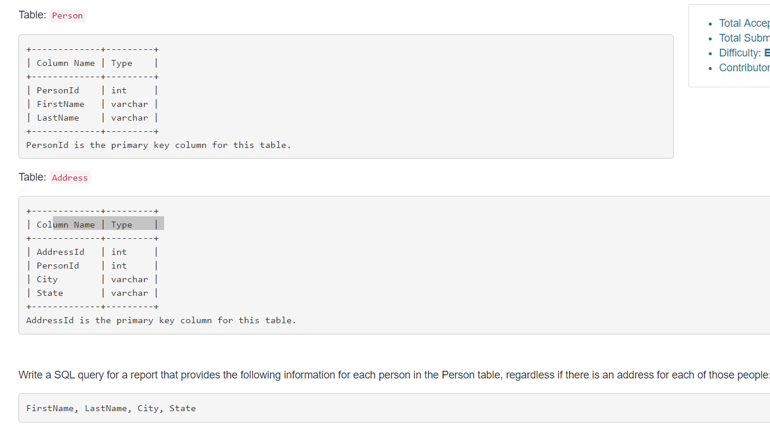

* Select p.FirstName, p.LastName, a.City, a.State

from Person p left outer join

Address a on p.personId = a.personId;